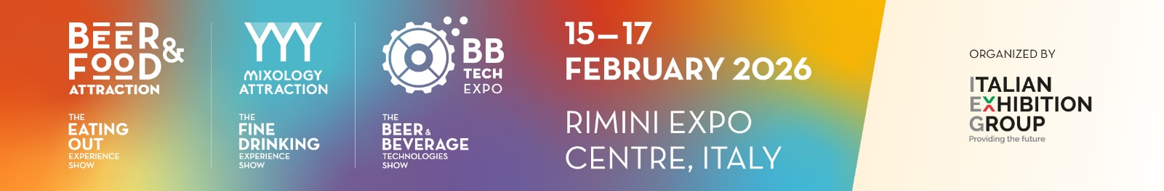

MY AGENDA BY IEG

Conditions of participation
I commit myself:
- to arrange 12 business meetings with Beer&Food Attraction/BB Tech exhibitors through My Agenda by IEG web platform from 27th January to 12th February 2026
- to send at least 8 meeting requests to the Beer&Food Attraction /BB Tech exhibitors within 4th February 2026
- to effectively do 12 business meetings divided in the following way: 7 business meetings on the first day + 5 business meetings on the second day (half day session)
- to respect the agreed time schedule of my meetings with the exhibiting companies during show days (if I will not be able to fix 12 meetings through My Agenda by IEG web platform, I commit myself to visit other exhibiting companies in order to achieve the total number of 12 meetings)
- to scan the QR code that is on the exhibitor’s badge at the end of each business meeting. If the scan is not successful, to ask for the signature on the paper agenda and/or a business card.
- to deliver the completed business agenda to the Italian Exhibition staff filled-in with all the signatures or scans of the meetings done
- to fill-in the on-line customer satisfaction survey after the completion of my business meetings.

Only if I participate in the pre-scheduled B2B meetings to the time agreed and I actively arrange these meetings through My Agenda by IEG web platform, Italian Exhibition Group will offer the following services:
- 3-night accommodation – bed and breakfast treatment;
- lump sum reimbursement up to € 200 for flight expenses in economy class *
- Interpreting service for the business meeting days only if I do not speak English fluently;
- Buffet lunch at the fair;
- Transfers from the airport (Bologna/Ancona/Rimini) to the Hotel/Expo Centre;
- Daily transfers (with the shuttle bus) from the Hotel to the Expo Centre and back;
- Free entrance ticket
- Access to the International Buyers Lounge: cloakroom, PCs, Wi-Fi connections and free refreshments (coffee, tea and no-alcoholic beverages)

*Flight lump sum reimbursement: the reimbursement of the lump sum will be made in cash during Beer & Food Attraction and only upon receipt of an invoice (with TIN no., invoice no., company and postal address), a copy of the passport and a copy of the flight ticket by 26th January 2026. (If the flight amount is less than €200, the amount actually spent will be refunded, if it is higher, the sum of €200 will be refunded)

Accompanying persons: If you travel with another person, for whom Italian Exhibition Group Spa will take on no charge and grant no benefits, you will have to submit the personal details of the second person at the same time as when you forward your own travel details. A maximum of 2 accompanying people will be granted access to the buyers’ lounge. Accompanying persons under 18 years of age are not allowed to enter the buyers’ lounge.

After signing up, IEG - Italian Exhibition Group Spa will use my personal data contained in this form, for publication on My Agenda by IEG online platform so that they can be consulted by exhibitors. For organizational purposes (e.g. hotel bookings, transfers, interpreting services), once I have signed up for the event, IEG will disclose said data to third party persons/entities/ providers.

I confirm that should the event be cancelled or postponed due to force majeure, IEG will promptly notify me by email, or I may receive notice by email from the reference person of my country's delegation. Under such circumstances I will not receive a contribution for the airline ticket and IEG will not be required to cover any costs I may have incurred (for example, for the visit, journey to airport, etc.) IEG will not be required to provide me with any of the aforementioned services.

